

Project:-3

**Integrate Grafana with Linux Server for high cpu utilization and create a graph in Grafana.**

Sign in to AWS Management Console

1. Click on the Open Console button, and you will get redirected to AWS Console in a new browser tab.

* On the AWS sign-in page, Leave the Account ID as default. Never edit/remove the 12-digit Account ID present in the AWS Console. otherwise, you cannot proceed with the lab.
* Now copy your User Name and Password in the Lab Console to the IAM Username and Password in AWS Console and click on the Sign in button.

2. Once Signed in to the AWS Management Console, Make the default AWS Region as US East (N. Virginia) us-east-1.

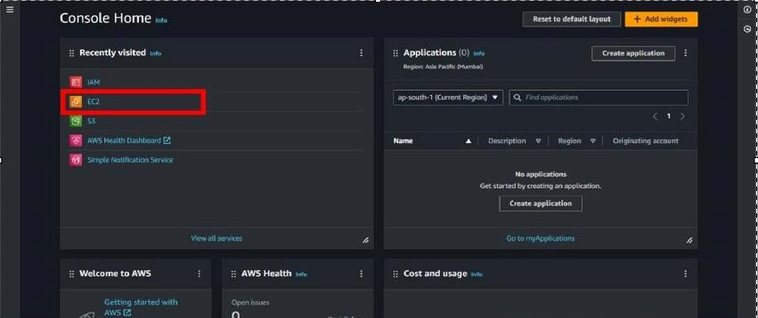

Create an EC2 Instance(ubuntu):

* For creating an EC2 instance follow the following steps as shown in snapshots.

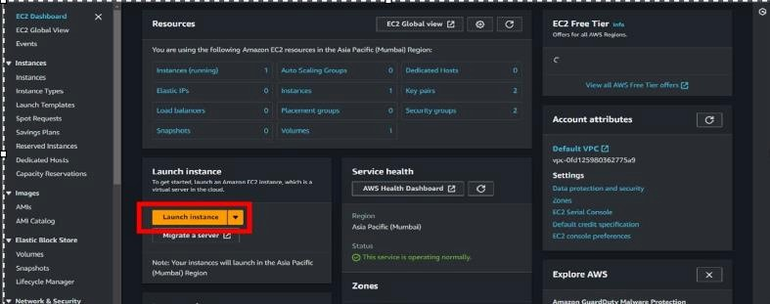

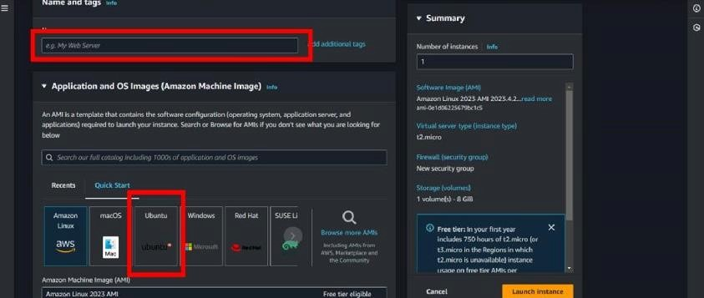

* Provide the EC2 name of your choise and select”**Ubuntu”**as an OS Image.

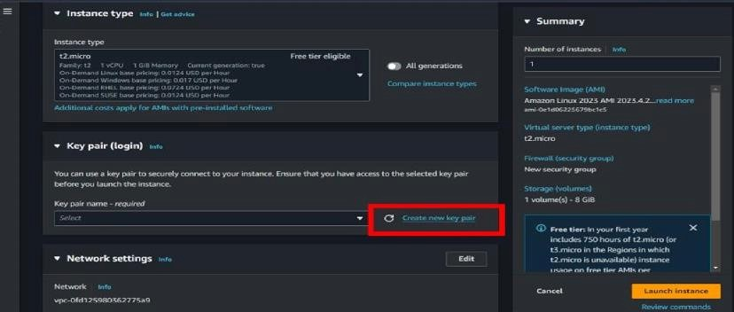

* Create a new key pair.

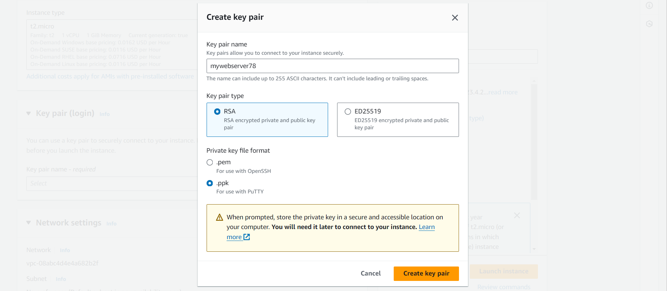

* Scroll down and click on “**LAUNCH INSTANCE** “.

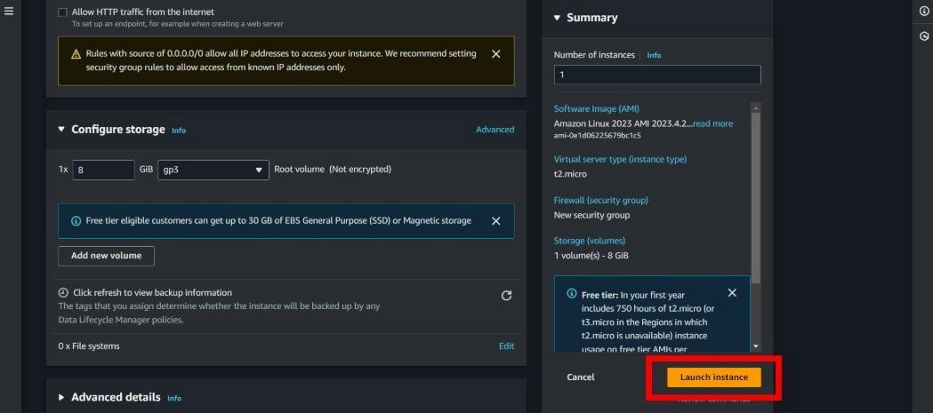

* Then open your instance and connect that instance by putty or on web browser.
* After connecting the instance follow the given command or read Grafana documentation for help.

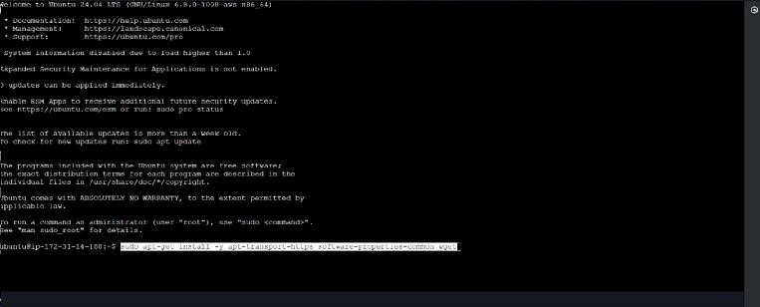

*sudo apt-get install -y apt-transport-https software-properties-common wget*

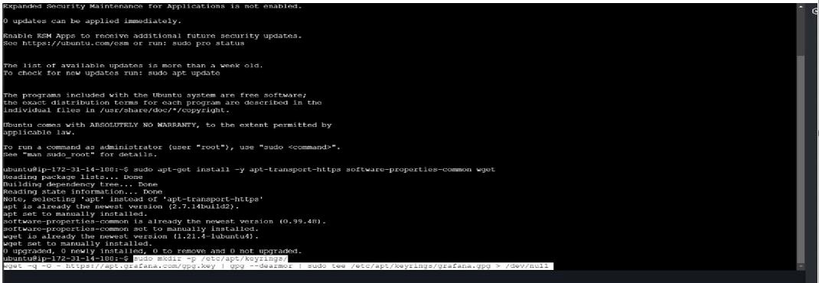

*sudomkdir -p /etc/apt/keyrings/wget -q -O - https://apt.grafana.com/gpg.key | gpg --dearmor | sudo tee /etc/apt/keyrings/grafana.gpg> /dev/null*

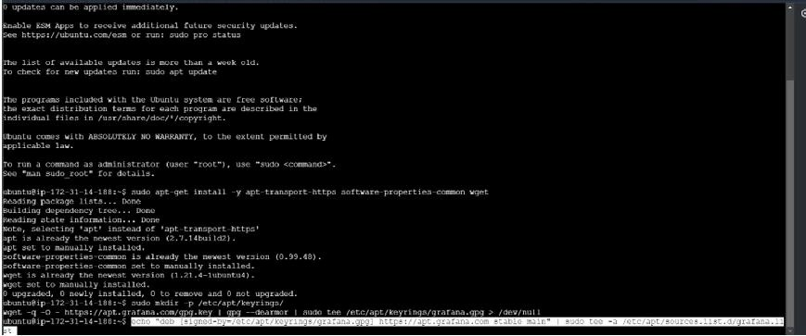

*echo "deb [signed-by=/etc/apt/keyrings/grafana.gpg] https://apt.grafana.com stable main" | sudo tee -a /etc/apt/sources.list.d/grafana.list*

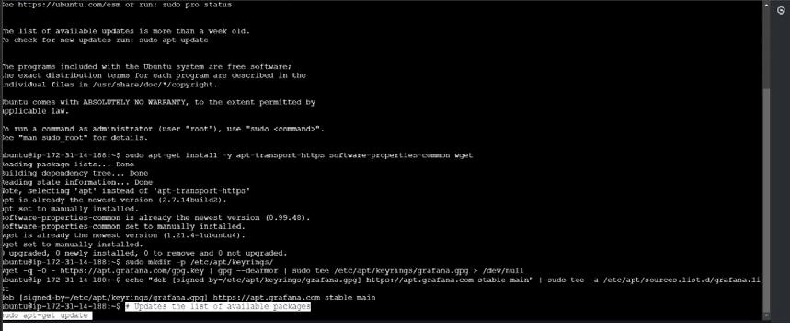

# To updates the list of available packages *sudo apt-get update*

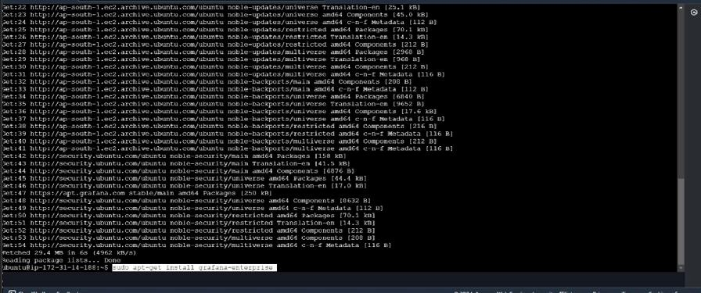

# To installs the latest Enterprise release: *sudo apt-get install grafana-enterprise*

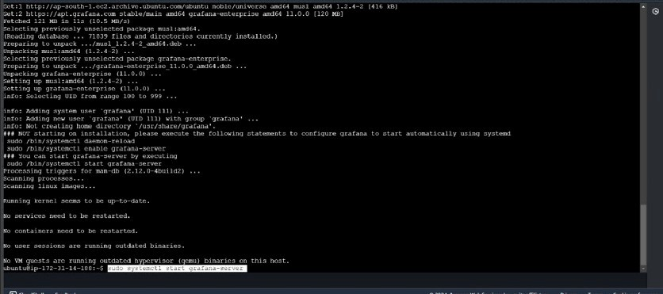

* *sudosystemctl start grafana-server*
* *sudosystemctl enable grafana-server.service*

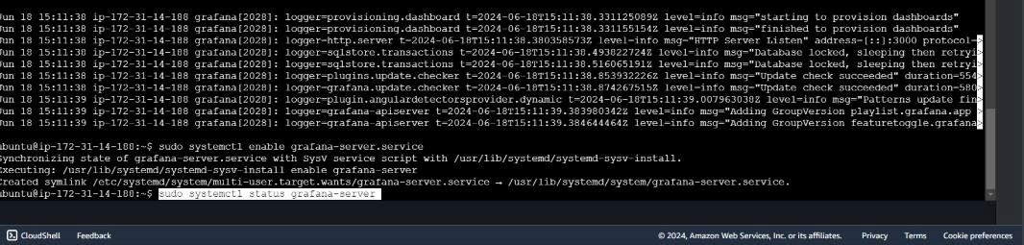

*sudosystemctl status grafana-server.service*

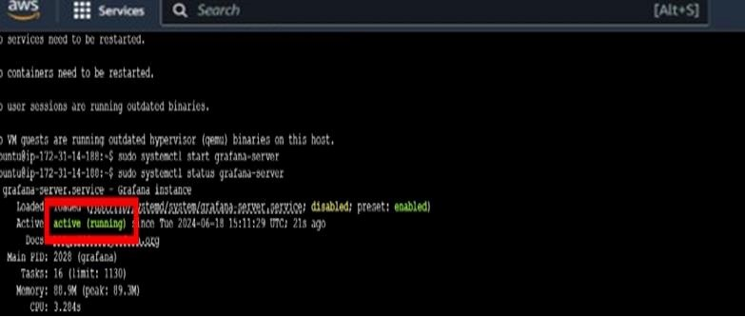

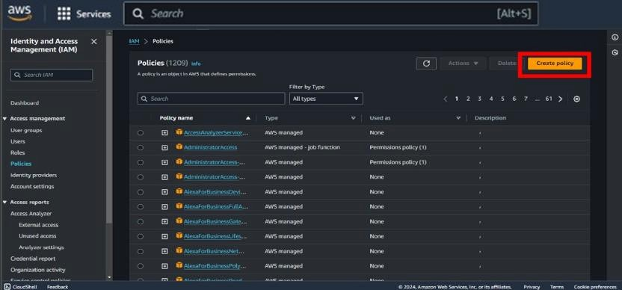

* Then search IAM role and go to policies and click on **Create policies**.

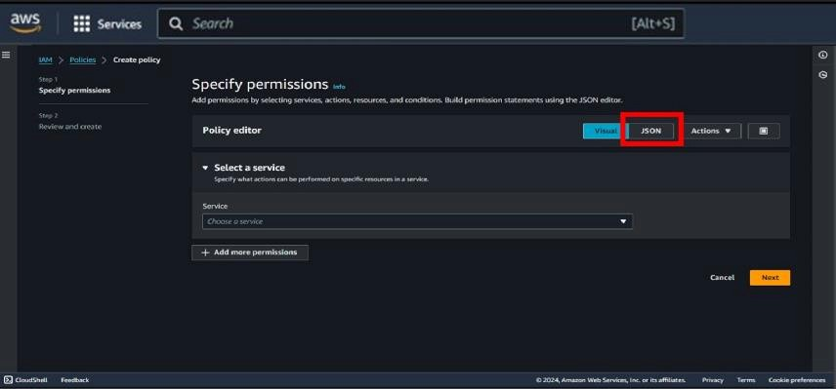

* Then go to **JSON** type.

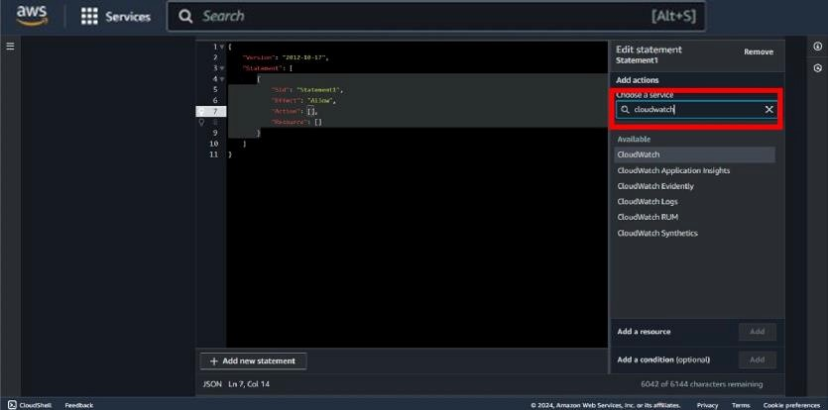

* Click on add action and search for **“Cloudwatch”**.

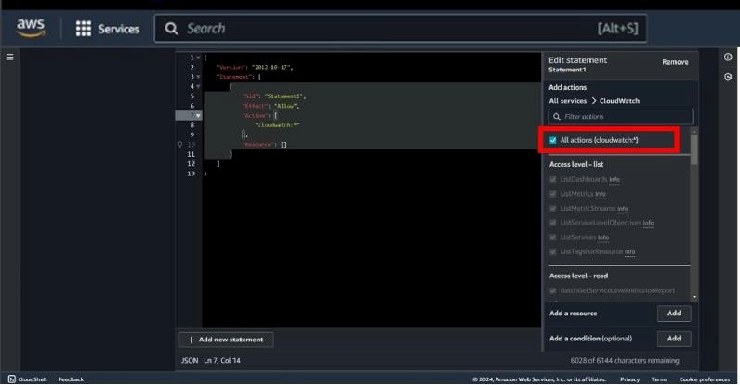

* After selecting cloudwatch select **“All actions “.**

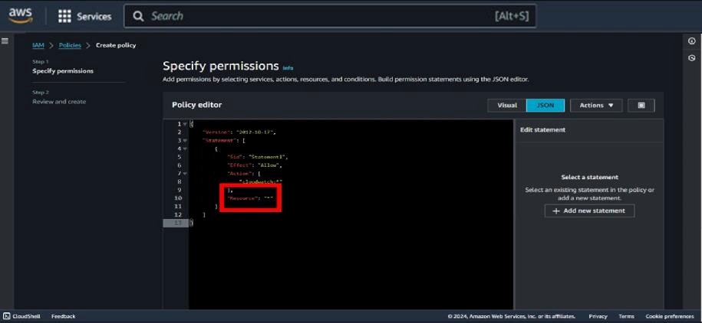

* Then put **“Resource “ : ”*”**

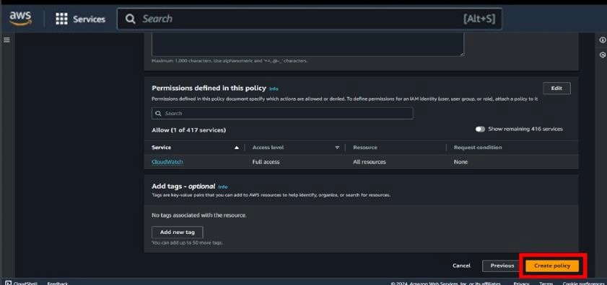

* Scroll down and click on **Create policy.**

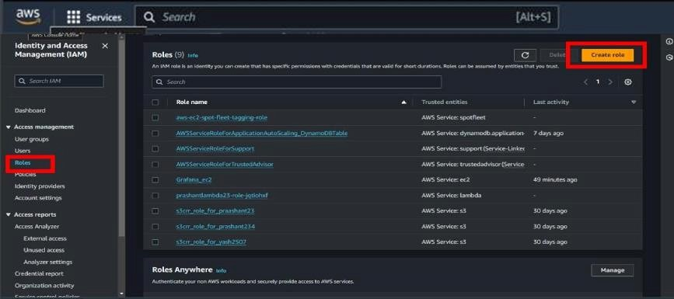

* Then go to roles and click on **Create roles.**

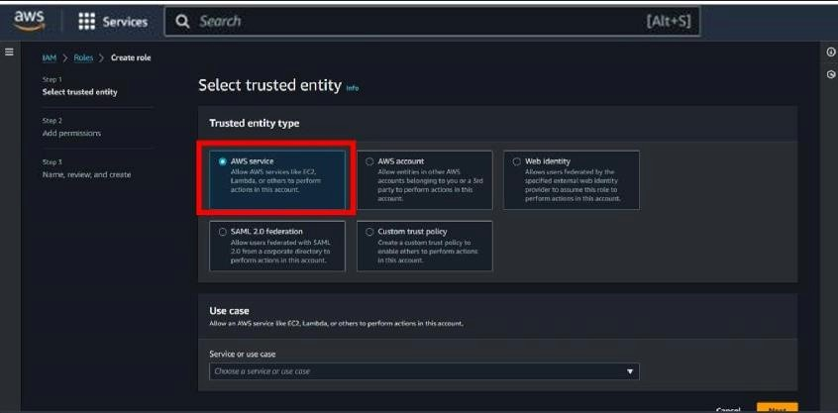

* Then select entity type is **AWS services .**

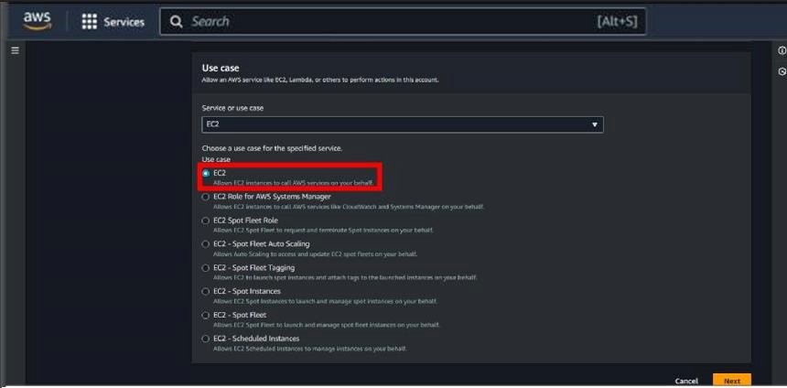

* Now , select use case as **EC2 .**

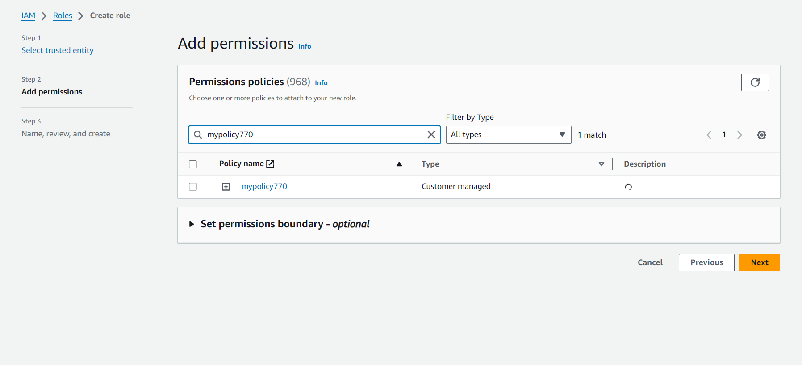

* Select your policy here which you have created previously , then click on **Next**.

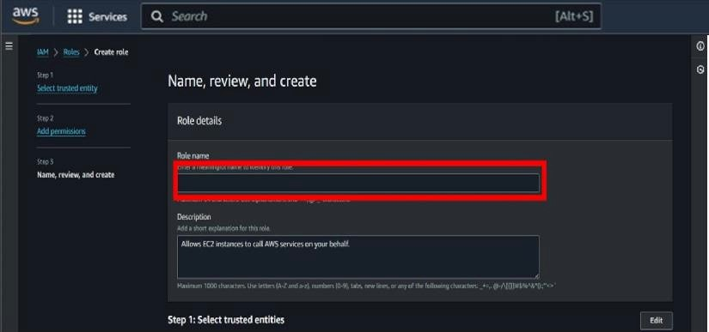

* Then give a name of your choise to the role .

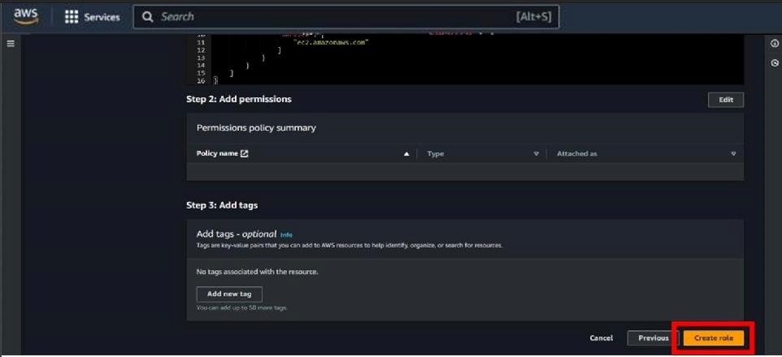

* Then scroll down and click on the **Create role** .

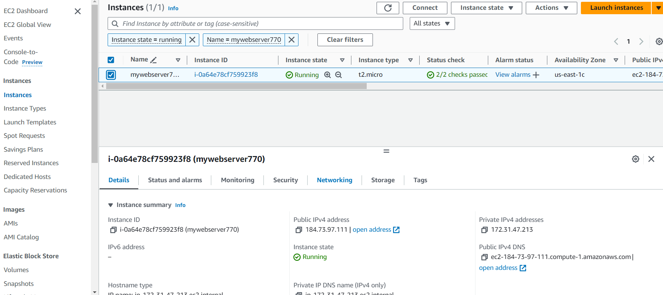+

* After creating your role and policy go to instance and open your instance , which you have already created.

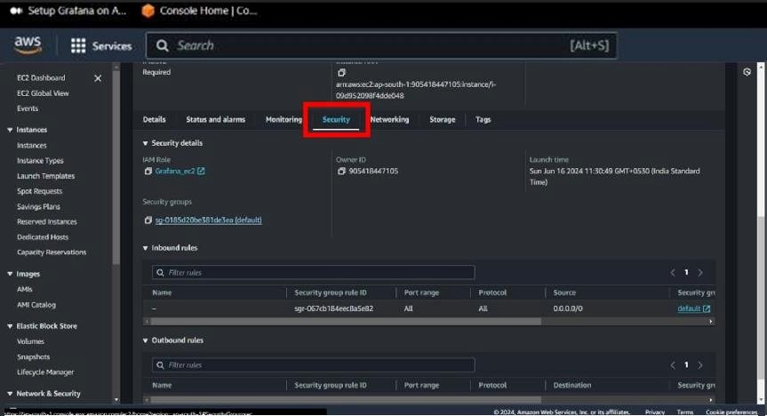

* Scroll down and go to **Security** option.

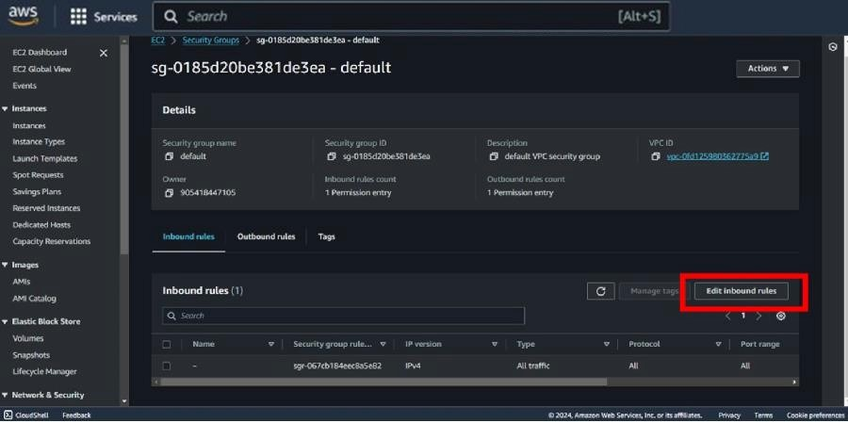

* Then click on **Edit inbound rule** .

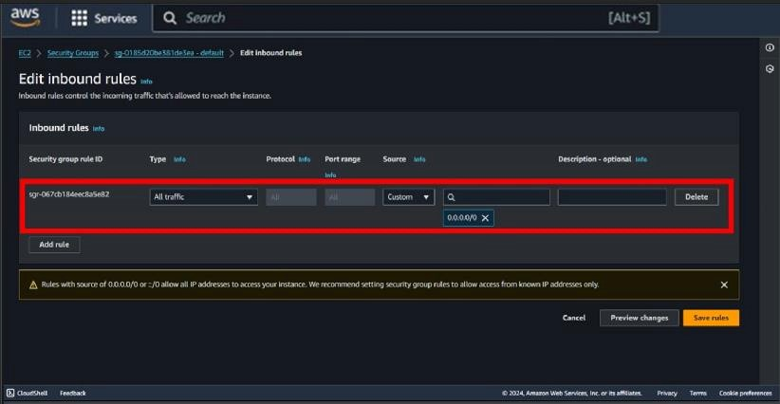

* Then modify your rule **select type = All traffic** and **source =0.0.0.0/0**

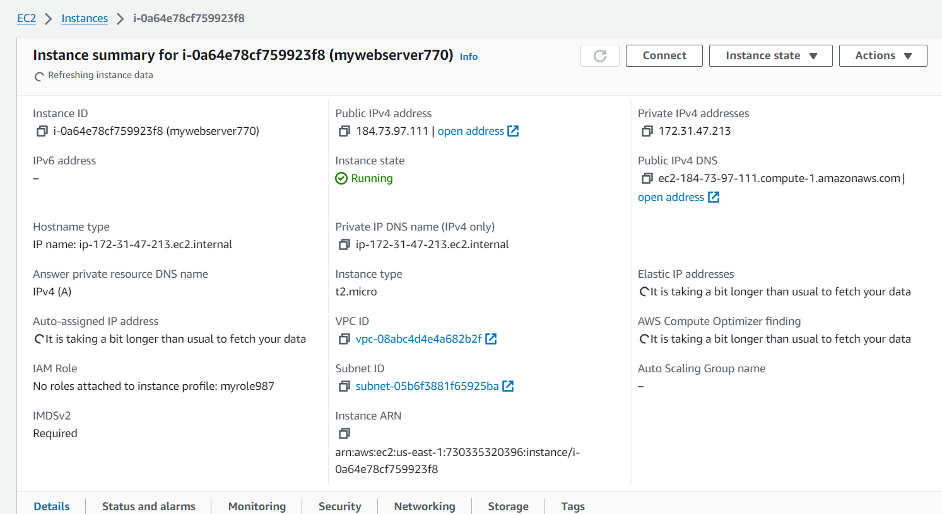

* Then copy your **public IPv4 address** of your instance .

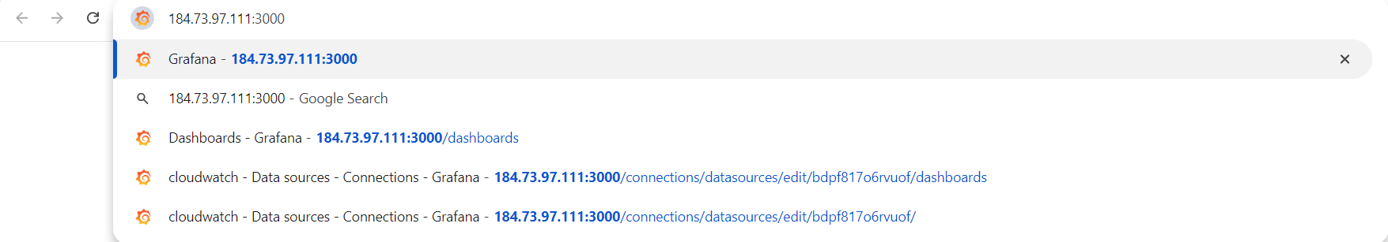Then paste your copied ip address and type “**:3000”** after ip address and search it .

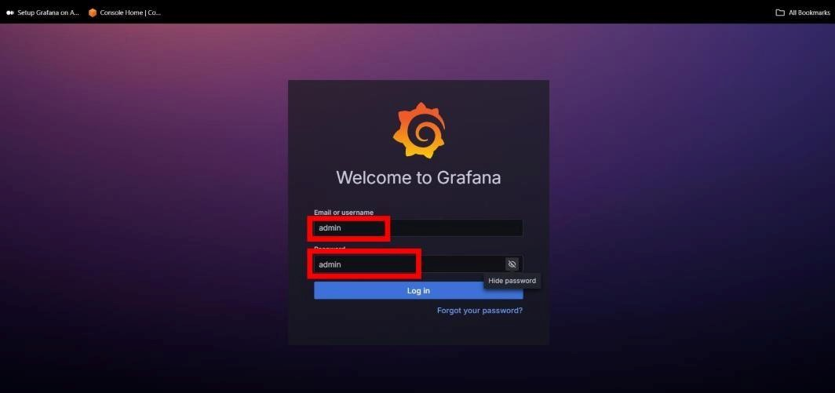

* Then login in Grafana by the help of credientials shown in above snapshot.

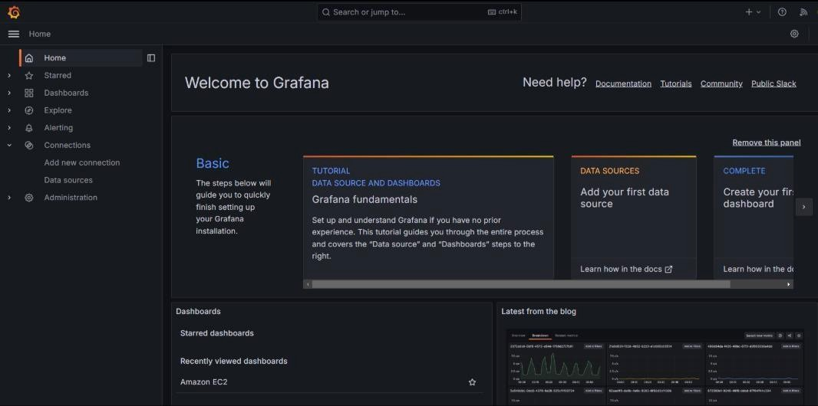

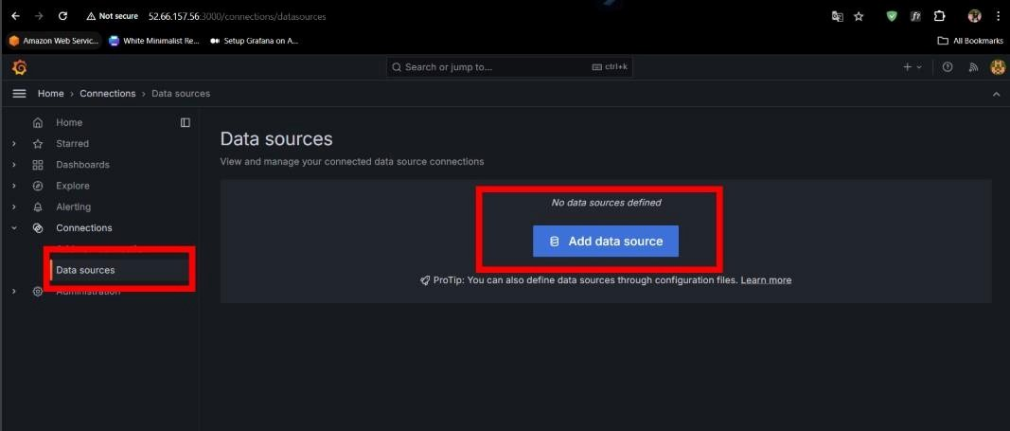

* Then go to **Dashboard** and click on **Adddata source** .

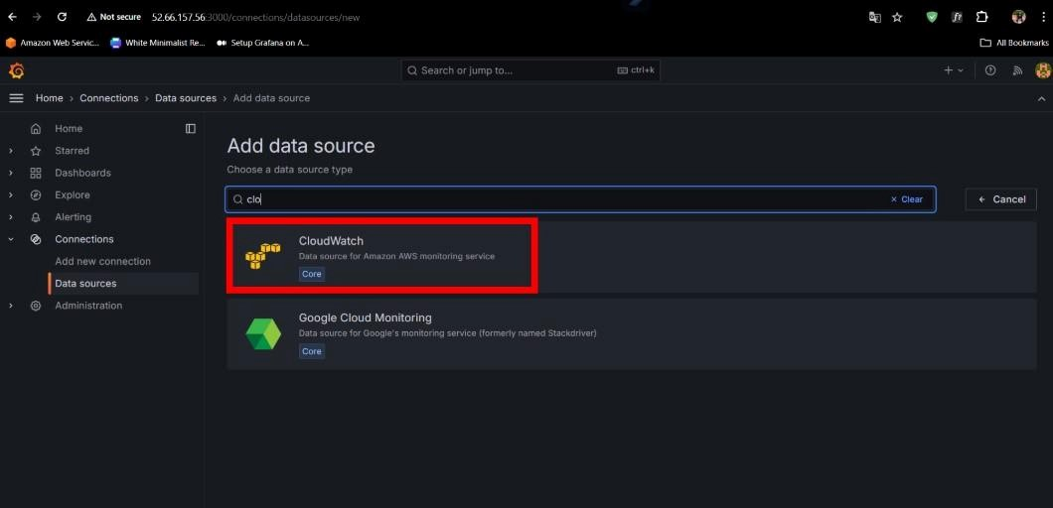

* Now , select “**Cloudwatch**” as an data source .

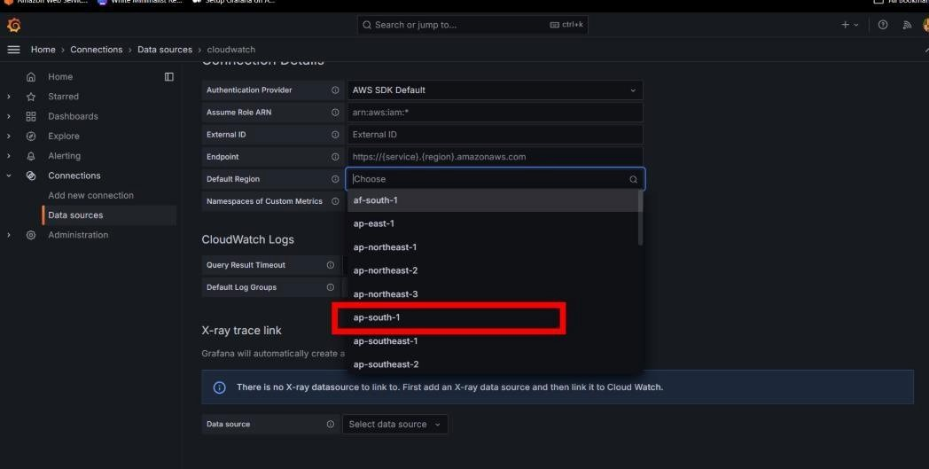

* Then after selecting cloudwatch select your region .

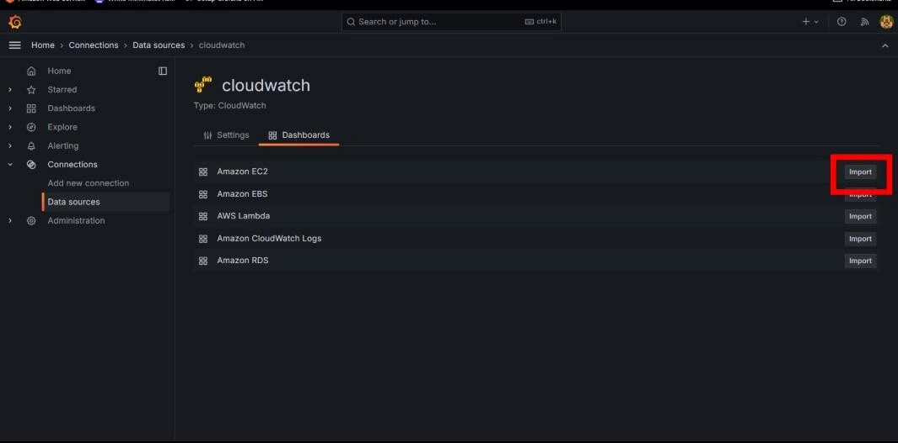

* Then inside your cloudwatch go to dashboard and **Import EC2**.

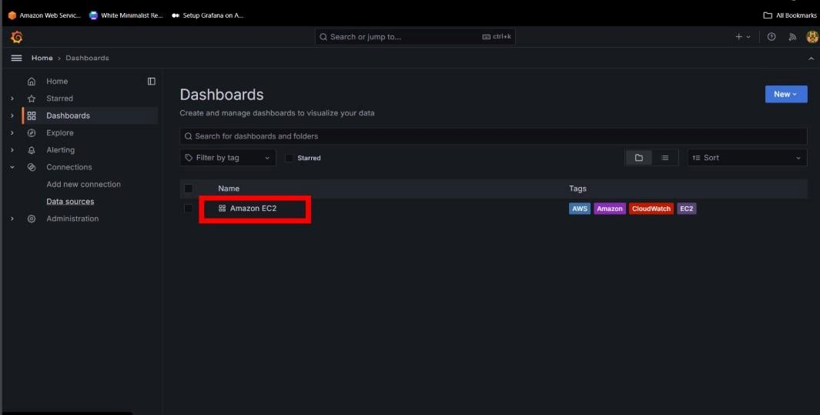

* Then go to dashboard and open your **Amazon EC2**.

